**National University of Computer and Emerging Sciences**



Laboratory Manual

for

Data Structures Lab

|  |  |
| --- | --- |
| Course Instructor | Ms. Syeda Tayyaba Bukhari |
| Lab Instructor(s) | Ms. Fariha Maqbool |
| Section | BCS-3A |
| Semester | Fall 2022 |

**Department of Computer Science**

FAST-NU, Lahore, Pakistan

**Objectives:**

In this lab, students will practice:

1. Single Linked List

**Linked list Data Structure**

A linked list is a linear data structure that includes a series of connected nodes. Here, each node stores the data and the address of the next node. For example,

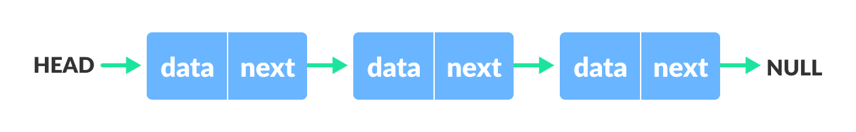Linked list Data Structure

You have to start somewhere, so we give the address of the first node a special name called HEAD. Also, the last node in the linked list can be identified because its next portion points to NULL.

**Task 1**

1. Implement a Friend class ‘List’ with nested ‘Node’ class that contains two data members: A template variable ‘data’ and a Node pointer ‘next’. You may define any member functions, if required, for the template class.
2. Now using the above class, implement a singly linked list which supports the following operations:
3. Insert at start void insertAtStart(T const element);
4. Insert at end void insertAtEnd(T const element);
5. Print void print() const;
6. Delete at start void deleteAtStart();
7. Delete at end void deleteAtEnd();
8. Search an element bool search(T const& element) const;
9. Check whether the list is empty bool isEmpty() const;
10. Make a function Union that takes two arguments link list **A** and link list **B** and return a new link list **C** that is union of link list **A** and **B (Order of elements in linked list C does not matter)**
11. Now create a main function which has the following instructions:
    1. Define a linked list object of type int.
    2. Insert 4, 7, and 9 at start
    3. Insert 2 at the end.
    4. Now insert 3, 7, and 1 at start.
    5. Now print the linked list.
    6. Delete an element from start.
    7. Delete an element from end.
    8. Search for 2, 9 and 7.
    9. Create two new linked lists and print the union of these two lists